**Introduction:**

Surface chemistry is the study of physical and chemical phenomena that occur at the interface of two phases, including solid–liquid interfaces, solid–gas interfaces, solid–vacuum interfaces, and liquid–gas interfaces. It includes the fields of surface chemistry and surface physics. Some related practical applications are classed as surface engineering. The science encompasses concepts such as heterogeneous catalysis, semiconductor device fabrication, fuel cells, self-assembled monolayers, and adhesives.Surface science is closely related to interface and colloid science.Interfacial chemistry and physics are common subjects for both. The methods are different. In addition, interface and colloid science studies macroscopic phenomena that occur in heterogeneous systems due to peculiarities of interfaces.

A branch of chemistry that deals with the properties of surfaces or phase boundaries and with the chemical changes occurring at a surface or interface is known as Surface chemistry.It deals with the study of phenomena that occur at the surfaces or interfaces of substances, like adsorption, heterogeneous catalysis, formation of substances, like adsorption, heterogeneous catalysis, formation of colloids, corrosion, crystallization, dissolution, electrode processes, chromatography etc. Surface chemistry finds its applications in industry as well as in daily life. The field of surface chemistry started with heterogeneous catalysis pioneered by Paul Sabatier on hydrogenation and Fritz Haber on the Haber process.Irving Langmuir was also one of the founders of this field, and the scientific journal on surface science, Langmuir, bears his name. The Langmuir adsorption equation is used to model monolayer adsorption where all surface adsorption sites have the same affinity for the adsorbing species and do not interact with each other. Gerhard Ertl in 1974 described for the first time the adsorption of hydrogen on a palladium surface using a novel technique called LEED. Similar studies with platinum, nickel, and iron followed. Most recent developments in surface sciences include the 2007 Nobel prize of Chemistry winner Gerhard Ertl's advancements in surface chemistry, specifically his investigation of the interaction between carbon monoxide molecules and platinum surface

The phenomena that occur at the surfaces or interfaces. The interface or surface is represented by separating the bulk phases by a hyphen or a slash. For example, the interface between a solid and a gas may be represented by solid-gas or solid/gas. Due to complete miscibility, there is no interface between the gases. The bulk phases that we come across in surface chemistry may be pure compounds or solutions. The interface is normally a few molecules thick but its area depends on the size of the particles of bulk phases. Many important phenomena, noticeable amongst these being corrosion, electrode processes, heterogeneous catalysis, dissolution and crystallisation occur at interfaces. The subject of surface chemistry finds many applications in industry, analytical work and daily life situations. To accomplish surface studies meticulously, it becomes imperative to have a really clean surface. Under very high vacuum of the order of 10–8 to 10–9 pascal, it is now possible to obtain ultra clean surface of the metals. Solid materials with such clean surfaces need to be stored in vacuum otherwise these will be covered by molecules of the major components of air namely dioxygen and dinitrogen.

In this Case Study, you will be studying some important features of surface chemistry such as adsorption, catalysis and colloids including emulsions and gels.

**Absorption:**

Absorption is a condition in which something takes in another substance. It is a physical or chemical phenomenon or process,in which atoms, molecules, or ions enter in the inner part (called "bulk") of a gas, liquid, or solid material.

This is a different process from adsorption. Molecules undergoing absorption are going deep into the volume of the material, instead in the case of adsorption molecules stop at the surface of the material. A more general term is sorption, which covers absorption, adsorption, and ion exchange.

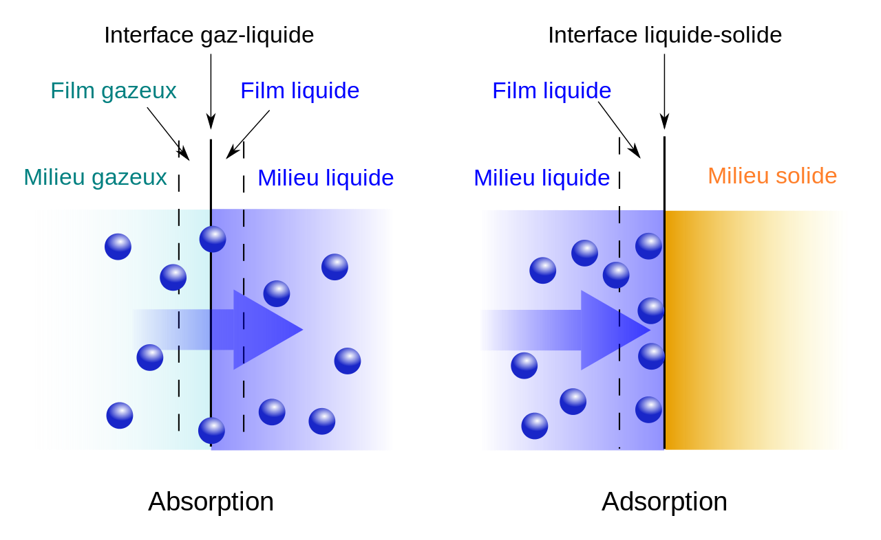

**Adsorption:**

Adsorption is defined as the deposition of molecular species onto the surface. The molecular species that gets adsorbed on the surface is known as Adsorbent and the surface on which adsorption occurs is known as Adsorbate. Common examples of adsorbents are clay, silica gel, colloids, metals etc.

Adsorption is essentially a surface phenomenon. Solids, particularly in finely divided state, have large surface area and therefore, charcoal, silica gel, alumina gel, clay, colloids, metals in finely divided state, etc. act as good adsorbents. Adsorption in action

1. If a gas like O2, H2, CO, Cl2, NH3 or SO2 is taken in a closed vessel containing powdered charcoal, it is observed that the pressure of the gas in the enclosed vessel decreases. The gas molecules concentrate at the surface of the charcoal, i.e., gases are adsorbed at the surface.
2. In a solution of an organic dye, say methylene blue, when animal charcoal is added and the solution is well shaken, it is observed that the filtrate turns colourless. The molecules of the dye, thus, accumulate on the surface of charcoal, i.e., are adsorbed.
3. Aqueous solution of raw sugar, when passed over beds of animal charcoal, becomes colourless as the colouring substances are adsorbed by the charcoal.
4. The air becomes dry in the presence of silica gel because the water molecules get adsorbed on the surface of the gel.



**Desorption:**

The process of removing an adsorbed substance from a surface on which it is adsorbed is called desorption. Desorption is a phenomenon whereby a substance is released from or through a surface. The process is the opposite of sorption (that is, either adsorption or absorption). This occurs in a system being in the state of sorption equilibrium between bulk phase (fluid, i.e. gas or liquid solution) and an adsorbing surface (solid or boundary separating two fluids). When the concentration (or pressure) of substance in the bulk phase is lowered, some of the sorbed substance changes to the bulk state.

In chemistry, especially chromatography, desorption is the ability for a chemical to move with the mobile phase. The more a chemical desorbs, the less likely it will adsorb, thus instead of sticking to the stationary phase, the chemical moves up with the solvent front.In chemical separation processes, stripping is also referred to as desorption as one component of a liquid stream moves by mass transfer into a vapor phase through the liquid-vapor interface.After adsorption, the adsorbed chemical will remain on the substrate nearly indefinitely, provided the temperature remains low. However, as the temperature rises, so does the likelihood of desorption. The general equation for the rate of desorption is:

**R=rN^x**

Where,r is the rate constant for desorption, N is the concentration of the adsorbed material, and x is the kinetic order of desorption.

Usually, the order of the desorption can be predicted by the number of elementary steps involved:

Atomic or simple molecular desorption will typically be a first-order process (i.e., a simple molecule on the surface of the substrate desorbs into a gaseous form).Recombinative molecular desorption will generally be a second-order process (i.e., two hydrogen atoms on the surface desorb and form a gaseous H2 molecule).

The rate constant r may be expressed in the form:

**r=Ae^-Ea/kT**

where A is the "attempt frequency" ,the chance of the adsorbed molecule overcoming its potential barrier to desorption, Ea is the activation energy of desorption, k is the Boltzmann constant, and T is the temperature.

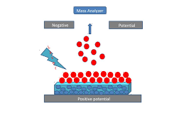

**Difference between Absorption and Adsorption:**



**Types of Adsorption:**

There are mainly two types of adsorption of gases on solids. If accumulation of gas on the surface of a solid occurs on account of weak van der Waals’ forces, the adsorption is termed as physical adsorption or physisorption. When the gas molecules or atoms are held to the solid surface by chemical bonds, the adsorption is termed chemical adsorption or chemisorption. The chemical bonds may be covalent or ionic in nature. Chemisorption involves a high energy of activation and is, therefore, often referred to as activated adsorption. Sometimes these two processes occur simultaneously and it is not easy to ascertain the type of adsorption. A physical adsorption at low temperature may pass into chemisorption as the temperature is increased. For example, dihydrogen is first adsorbed on nickel by van der Waals’ forces. Molecules of hydrogen then dissociate to form hydrogen atoms which are held on the surface by chemisorption. Some of the important characteristics of both types of adsorption are described below:

**Characteristics of physisorption:**

1. Lack of specificity: A given surface of an adsorbent does not show any preference for a particular gas as the van der Waals’ forces are universal.
2. Nature of adsorbate: The amount of gas adsorbed by a solid depends on the nature of gas. In general, easily liquefiable gases (i.e., with higher critical temperatures) are readily adsorbed as van der Waals’ forces are stronger near the critical temperatures. Thus, 1g of activated charcoal adsorbs more sulphur dioxide (critical temperature 630K), than methane (critical temperature 190K) which is still more than 4.5 mL of dihydrogen (critical temperature 33K).
3. Reversible nature: Physical adsorption of a gas by a solid is generally reversible. Thus, Solid + Gas l Gas/Solid + Heat More of gas is adsorbed when pressure is increased as the volume of the gas decreases (Le–Chateliers’s principle) and the gas can be removed by decreasing pressure. Since the adsorption process is exothermic, the physical adsorption occurs readily at low temperature and decreases with increasing temperature (Le-Chatelier’s principle).
4. Surface area of adsorbent: The extent of adsorption increases with the increase of surface area of the adsorbent. Thus, finely divided metals and porous substances having large surface areas are good adsorbents.
5. Enthalpy of adsorption: No doubt, physical adsorption is an exothermic process but its enthalpy of adsorption is quite low (20– 40 kJ mol-1). This is because the attraction between gas molecules and solid surface is only due to weak van der Waals’ forces

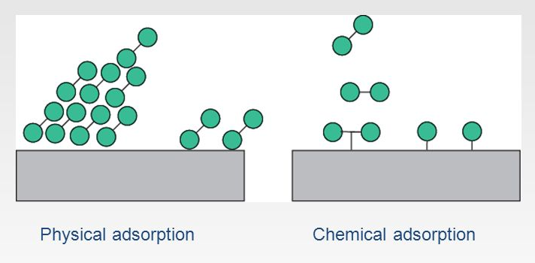

**Characteristics of chemisorption :**

1. High specificity: Chemisorption is highly specific and it will only occur if there is some possibility of chemical bonding between adsorbent and adsorbate. For example, oxygen is adsorbed on metals by virtue of oxide formation and hydrogen is adsorbed by transition metals due to hydride formation.
2. Irreversibility: As chemisorption involves compound formation, it is usually irreversible in nature. Chemisorption is also an exothermic process but the process is very slow at low temperatures on account of high energy of activation. Like most chemical changes, adsorption often increases with rise of temperature. Physisorption of a gas adsorbed at low temperature may change into chemisorption at a high temperature. Usually high pressure is also favourable for chemisorption.
3. Surface area: Like physical adsorption, chemisorption also increases with increase of surface area of the adsorbent.

1. Enthalpy of adsorption: Enthalpy of chemisorption is high (80-240 kJ mol-1) as it involves chemical bond formation.



**Difference between Physical and Chemical 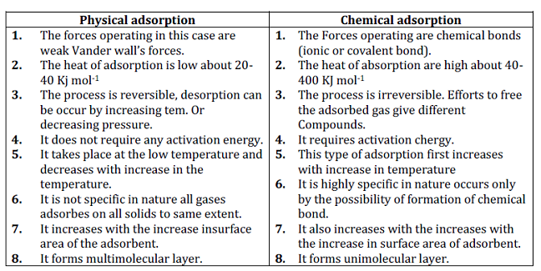Adsorption:**

**Adsorption Isotherms:**

The process of adsorption is usually plotted and studied using a [graph](https://www.toppr.com/guides/quantitative-aptitude/data-interpretation/bar-graph/). This is called adsorption isotherm. Different [scientists](https://www.toppr.com/bytes/7-indian-scientists-changed-world/) have developed different kinds of adsorption isotherms. Let’s go ahead and learn about this concept in detail.

## Freundlich Adsorption Isotherm

In 1909, German scientist Freundlich provided an empirical relationship between the amount of [gas](https://www.toppr.com/guides/chemistry/states-of-matter/the-gaseous-state/) adsorbed by a unit mass of [solid](https://www.toppr.com/guides/chemistry/the-solid-state/) adsorbent and pressure at a particular temperature. It is expressed using the following equation –

**x/m = k.P1/n (n > 1)**

where ‘x’ is the mass of the gas adsorbed on mass ‘m’ of the adsorbent at pressure ‘P’. ‘k’ and ‘n’ are constants that depend on the [nature](https://www.toppr.com/guides/essays/essay-on-conservation-of-nature/) of the adsorbent and the gas at a particular temperature.

The mass of the gas adsorbed per gram of the adsorbent is plotted against pressure in the form of a curve to show the relationship. Here, at a fixed pressure, physical adsorption decreases with increase in temperature. The [curves](https://www.toppr.com/guides/maths/basic-geometrical-ideas/curves/) reach saturation at high pressure. Now, if you take the [log](https://www.toppr.com/guides/business-mathematics-and-statistics/business-mathematics/logarithms-and-anti-logarithms/) of the above equation –

**log x/m = log k + 1/n log P**

To test the validity of Freundlich isotherm, we can plot log x/m on the y-axis and log P on the x-axis. If the plot shows a straight line, then the Freundlich isotherm is valid, otherwise, it is not. The [slope of the straight line](https://www.toppr.com/guides/maths/straight-lines/basics-of-straight-lines/) gives the value of 1/n, while the intercept on the y-axis gives the value of log k.

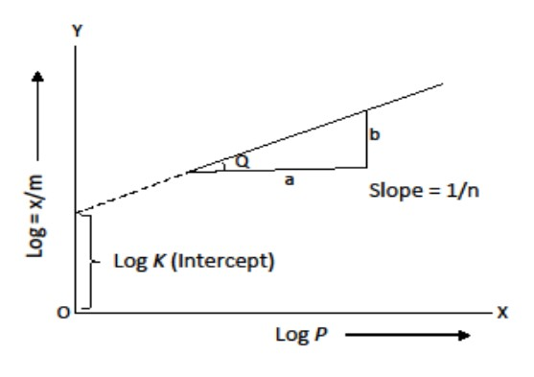

### Limitations of Freundlich Isotherm

Freundlich isotherm only approximately explains the behaviour of adsorption. The value of 1/n can be between 0 and 1, therefore the equation holds good only over a limited range of pressure.

* When 1/n = 0, x/m is constant, the adsorption is independent of pressure.
* When 1/n =1, x/m = k P, i.e. x/m ∝ P, adsorption is [directly proportional](https://www.toppr.com/guides/maths/direct-and-inverse-proportions/inversely-proportional/) to pressure.

Experimental results support both of the above mentioned conditions. At high pressure, the experimental isotherms always seem to approach saturation. Freundlich isotherm does not explain this observation and therefore, fails at high pressure.

The Freundlich isotherm was followed by two other isotherms – Langmuir adsorption isotherm and BET adsorption isotherm. Langmuir isotherm assumed that adsorption is monolayer in nature whereas BET isotherm assumed that it is multi-layer.

**Effects of Pressure and Temperature on Adsorption:**

**Effect of pressure on the adsorption of a gas on a solid:**

The fraction of gas adsorbed is proportional to the pressure of the gas. Adsorption increase with pressure reaches the maximum and becomes constant**.**

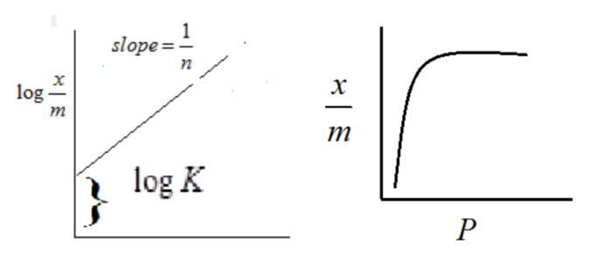

**Effect of temperature on adsorption of gases on solid:**

* Adsorption of gases on solid is always [exothermic](https://byjus.com/chemistry/exothermic-reaction/).
* Physical adsorption follows Lechatlier Principle, the amount of gas adsorbed decrease with the increase of temperature.
* Chemisorption increases with increase in the temperature. It reaches the maximum and then decreases.
* The curve obtained by plotting fraction of gas adsorbed and temperature at constant pressure is adsorption isobars.

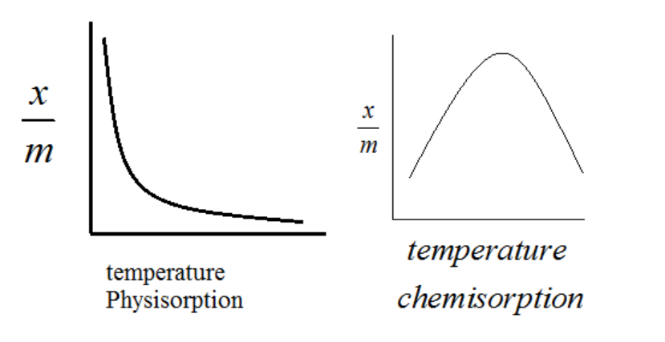

**Adsorption from solution phase:**

Solids can adsorb solutes from solutions also. When a solution of acetic acid in water is shaken with charcoal, a part of the acid is adsorbed by the charcoal and the concentration of the acid decreases in the solution. Similarly, the litmus solution when shaken with charcoal becomes colourless. The precipitate of Mg(OH)2 attains blue colour when precipitated in presence of magneson reagent. The colour is due to adsorption of magneson. The following observations have been made in the case of adsorption from solution phase:

1. The extent of adsorption decreases with an increase in temperature.
2. The extent of adsorption increases with an increase of surface area of the adsorbent.
3. The extent of adsorption depends on the concentration of the solute in solution.
4. The extent of adsorption depends on the nature of the adsorbent and the adsorbent

The precise mechanism of adsorption from solution is not known. Freundlich’s equation approximately describes the behaviour of adsorption from solution with a difference that instead of pressure, concentration of the solution is taken into account, i.e.,

**x/m = k C^1/n**

(C is the equilibrium concentration, i.e., when adsorption is complete). On taking logarithm of the above equation, we have

**log x/m = logk + 1 n logC**

Plotting log x m against log C a straight line is obtained which shows the validity of Freundlich isotherm. This can be tested experimentally by taking solutions of different concentrations of acetic acid. Equal volumes of solutions are added to equal amounts of charcoal in different flasks. The final concentration is determined in each flask after adsorption. The difference in the initial and final concentrations give the value of x. Using the above equation, validity of Freundlich isotherm can be established**.**

**Applications of Adsorption:**

The phenomenon of adsorption finds a number of applications. Important ones are listed here:

1. Production of high vacuum: The remaining traces of air can be adsorbed by charcoal from a vessel evacuated by a vacuum pump to give a very high vacuum.
2. Gas masks: Gas mask (a device which consists of activated charcoal or mixture of adsorbents) is usually used for breathing in coal mines to adsorb poisonous gases.
3. Control of humidity: Silica and aluminium gels are used as adsorbents for removing moisture and controlling humidity.
4. Removal of colouring matter from solutions: Animal charcoal removes colours of solutions by adsorbing coloured impurities.
5. Heterogeneous catalysis: Adsorption of reactants on the solid surface of the catalysts increases the rate of reaction. There are many gaseous reactions of industrial importance involving solid catalysts. Manufacture of ammonia using iron as a catalyst, manufacture of H2SO4 by contact process and use of finely divided nickel in the hydrogenation of oils are excellent examples of heterogeneous catalysis.
6. Separation of inert gases: Due to the difference in degree of adsorption of gases by charcoal, a mixture of noble gases can be separated by adsorption on coconut charcoal at different temperatures.
7. In curing diseases: A number of drugs are used to kill germs by getting adsorbed on them.
8. Froth floatation process: A low grade sulphide ore is concentrated by separating it from silica and other earthy matter by this method using pine oil and frothing agent.
9. Adsorption indicators: Surfaces of certain precipitates such as silver halides have the property of adsorbing some dyes like eosin, fluorescein, etc. and thereby producing a characteristic colour at the end point.
10. Chromatographic analysis: Chromatographic analysis based on the phenomenon of adsorption finds a number of applications in analytical and industrial fields.

**Catalysis**

Catalyst:- Catalyst is a substance which can change (enhance) the speed of a chemical reaction without itself undergoing any change in its mass and chemical composition. And the phenomena is called Catalysis

The systematic study of the effect of various foreign substances on the rates of chemical reactions was first made by Berzelius, in 1835. He suggested the term catalyst for such substances. Substances, which alter the rate of a chemical reaction and themselves remain chemically and quantitatively unchanged after the reaction, are known as catalysts, and the phenomenon is known as catalysis. You have already studied about catalysts and its functioning.

Promoters and poisons:

Promoters are substances that enhance the activity of a catalyst while poisons decrease the activity of a catalyst. For example, in Haber’s process for manufacture of ammonia, molybdenum acts as a promoter for iron which is used as a catalyst.

**N2(g) + 3H2(g) Fe(s) Mo(s) 2NH3(g)**

Positive Catalysis:- if a catalyst increases (accelerates) the speed of reaction is a called a positive catalyst and phenomena is called positive Catalysis.

Ex. Zymase, invertase.

Negative Catalysis:- if catalyst decreases the speed of a reaction, it is called a negative catalyst and the phenomenon is called negative catalysis.

Ex. Decomposition of H2O2 in presence of Glycerol or acetanilide.

**Types of Catalysis:**

Catalysis can be broadly divided into two groups:

1. **Homogeneous catalysis :**

When the reactants and the catalyst are in the same phase (i.e., liquid or gas), the process is said to be homogeneous catalysis.

The following are some of the examples of homogeneous catalysis:

1. Oxidation of sulphur dioxide into sulphur trioxide with dioxygen in the presence of oxides of nitrogen as the catalyst in the lead chamber process.

**2SO2(g) + O2(g) 🡪 2SO3(g)**

The reactants, sulphur dioxide and oxygen, and the catalyst, nitric oxide, are all in the same phase.

1. Hydrolysis of methyl acetate is catalysed by H+ ions furnished by hydrochloric acid.

**CH3COOCH3(l) + H2O(l)🡪 CH3COOH(aq) + CH3OH(aq)**

Both the reactants and the catalyst hydrogen chloride(HCL) are in the same phase.

1. Hydrolysis of sugar is catalysed by H+ ions furnished by sulphuric acid.

**C12H22O11(aq)+ H2O(l)🡪C5H12O6(aq)+C6H12O6(aq)**

Both the reactants and the catalyst sulphuric acid(H2SO4) are in the same phase.

1. **Heterogeneous catalysis:**

The catalytic process in which the reactants and the catalyst are in different phases is known as heterogeneous catalysis. Some of the examples of heterogeneous catalysis are given below:

1. Oxidation of sulphur dioxide into sulphur trioxide in the presence of Pt.

**2SO2(g) 🡪 2SO3(g)**

The reactant is in gaseous state while the catalyst platinum used here is in the solid state.

1. Combination between dinitrogen and dihydrogen to form ammonia in the presence of finely divided iron in Haber’s process**.**

**N (g) + 3H2(g)🡪2NH(g)**

The reactants are in gaseous state while the catalyst Fe i.e Iron used here is in the solid state.

1. Oxidation of ammonia into nitric oxide in the presence of platinum gauze in Ostwald’s process.

**4NH3(g) + 5O2(g) 🡪4NO (g) + 6H2O(g)**

The reactants are in gaseous state while the catalyst platinum used here is in the solid state.

1. Hydrogenation of vegetable oils in the presence of finely divided nickel as catalyst.

**Vegetable oils(l) + H2(g) 🡪Vegetable ghee(s)**

One of the reactants is in liquid state and the other in gaseous state while the catalyst nickel used here is in the solid state.

**Adsorption Theory of Heterogeneous Catalysis:**

This theory explains the mechanism of heterogeneous catalysis. The old theory, known as adsorption theory of catalysis, was that the reactants in gaseous state or in solutions, are adsorbed on the surface of the solid catalyst. The increase in concentration of the reactants on the surface increases the rate of reaction. Adsorption being an exothermic process, the heat of adsorption is utilised in enhancing the rate of the reaction. The catalytic action can be explained in terms of the intermediate compound formation, the theory of which you have already studied in Section 4.5.1 The modern adsorption theory is the combination of intermediate compound formation theory and the old adsorption theory. The catalytic activity is localised on the surface of the catalyst. The mechanism involves five steps:

1. Diffusion of reactants to the surface of the catalyst.
2. Adsorption of reactant molecules on the surface of the catalyst.
3. Occurrence of chemical reaction on the catalyst’s surface through formation of an intermediate.
4. Desorption of reaction products from the catalyst surface, and thereby, making the surface available again for more reaction to occur.
5. Diffusion of reaction products away from the catalyst’s surface. The surface of the catalyst unlike the inner part of the bulk, has free valencies which provide the seat for chemical forces of attraction. When a gas comes in contact with such a surface, its molecules are held up there due to loose chemical combination. If different molecules are adsorbed side by side, they may react with each other resulting in the formation of new molecules. Thus, formed molecules may evaporate leaving the surface for the fresh reactant molecules. This theory explains why the catalyst remains unchanged in mass and chemical composition at the end of the reaction and is effective even in small quantities. It however, does not explain the action of catalytic promoters and catalytic poisons.

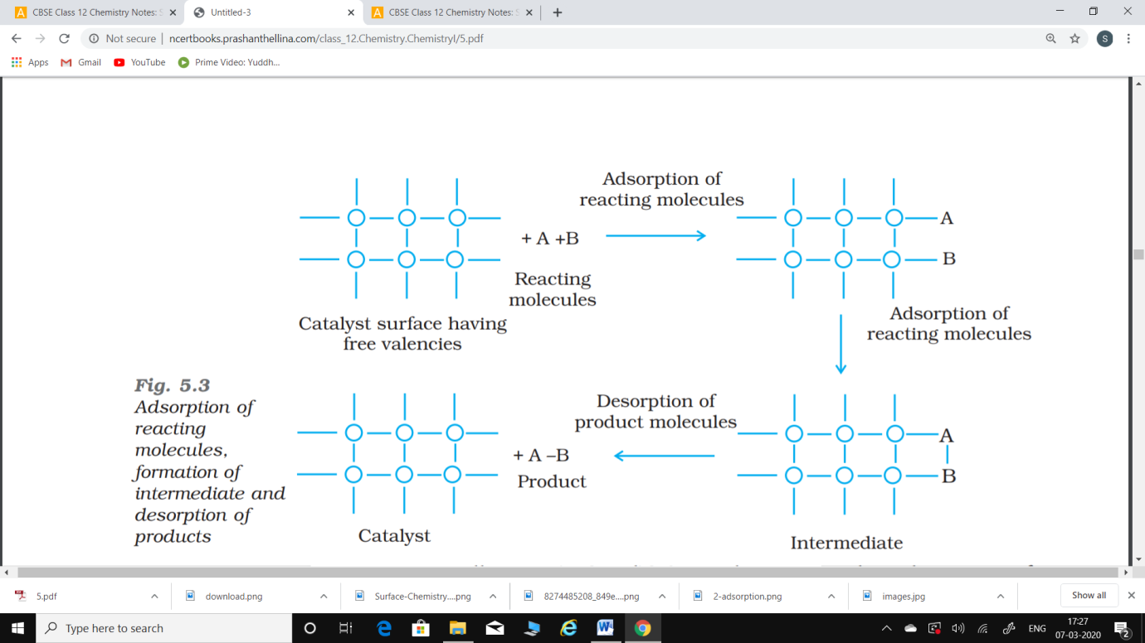

The above figure shows Adsorption of reacting molecules, formation of intermediate and desorption of products.

**Important features of solid catalysts** :

1. Activity:

The activity of a catalyst depends upon the strength of chemisorption to a large extent. The reactants must get adsorbed reasonably strongly on to the catalyst to become active. However, they must not get adsorbed so strongly that they are immobilised and other reactants are left with no space on the catalyst’s surface for adsorption. It has been found that for hydrogenation reaction, the catalytic activity increases from Group 5 to Group 11 metals with maximum activity being shown by groups 7-9 elements of the periodic table**.**

**2H2 (g) + O2(g)🡪 2H2O(l)**

1. Selectivity:

The selectivity of a catalyst is its ability to direct a reaction to yield a particular product. For example, starting with H2 and CO, and using different catalysts, we get different products.

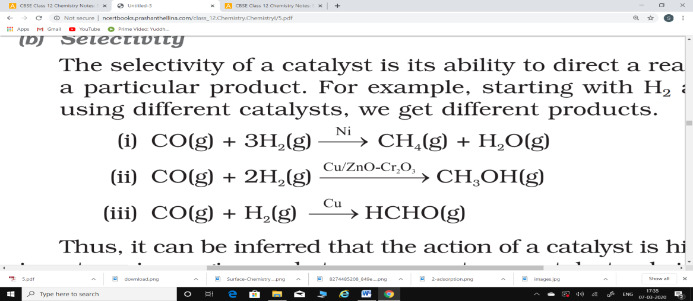

Thus, it can be inferred that the action of a catalyst is highly selective in nature, i.e., a given substance can act as a catalyst only in a particular reaction and not for all the reactions. It means that a substance which acts as a catalyst in one reaction may fail to catalyse another reaction.

**Shape Selective Catalysis by Zeolites:**

The catalytic reaction that depends upon the pore structure of the catalyst and the size of the reactant and product molecules is called shape-selective catalysis. Zeolites are good shape-selective catalysts because of their honeycomb-like structures. They are microporous aluminosilicates with three dimensional network of silicates in which some silicon atoms are replaced by aluminium atoms giving Al–O–Si framework. The reactions taking place in zeolites depend upon the size and shape of reactant and product molecules as well as upon the pores and cavities of the zeolites. They are found in nature as well as synthesised for catalytic selectivity.

Zeolites are being very widely used as catalysts in petrochemical industries for cracking of hydrocarbons and isomerisation. An important zeolite catalyst used in the petroleum industry is ZSM-5. It converts alcohols directly into gasoline (petrol) by dehydrating them to give a mixture of hydrocarbons.

**Enzyme Catalysis:**

Enzymes are complex nitrogenous organic compounds which are produced by living plants and animals. They are actually protein molecules of high molecular mass and form colloidal solutions in water. They are very effective catalysts; catalyse numerous reactions, especially those connected with natural processes. Numerous reactions that occur in the bodies of animals and plants to maintain the life process are catalysed by enzymes. The enzymes are, thus, termed as biochemical catalysts and the phenomenon is known as biochemical catalysis.

Many enzymes have been obtained in pure crystalline state from living cells. However, the first enzyme was synthesised in the laboratory in 1969.

The following are some of the examples of enzyme-catalysed reactions:

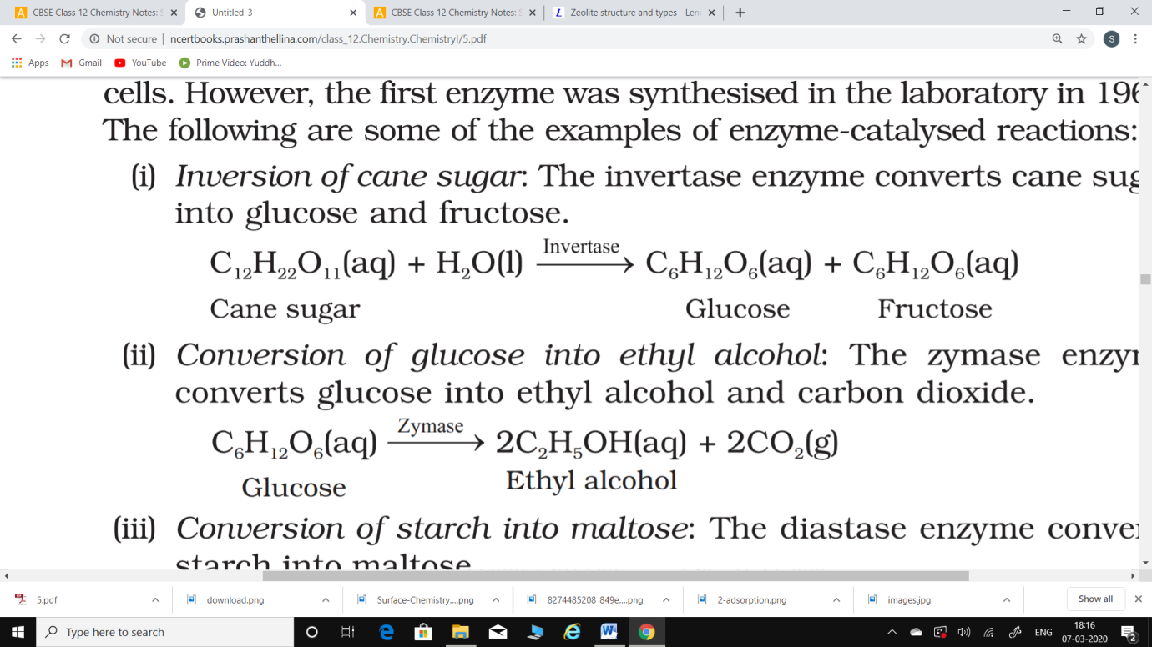(i) Inversion of cane sugar: The invertase enzyme converts cane sugar into glucose and fructose.

(ii) Conversion of glucose into ethyl alcohol: The zymase enzyme converts glucose into ethyl alchol and carbondioxide.

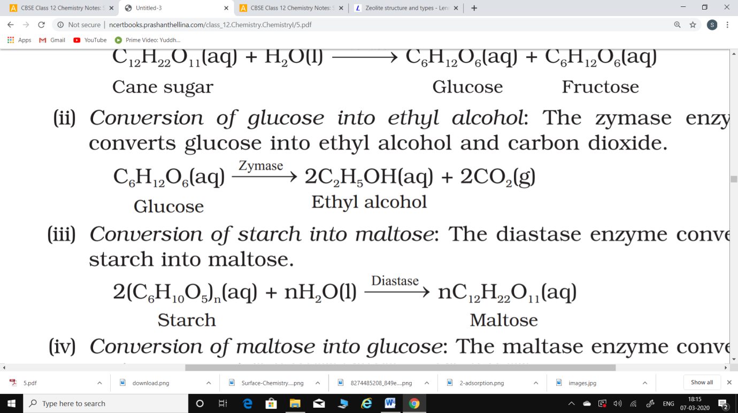

(iii) Conversion of starch into maltose: The diastase enzyme converts starch into maltose.

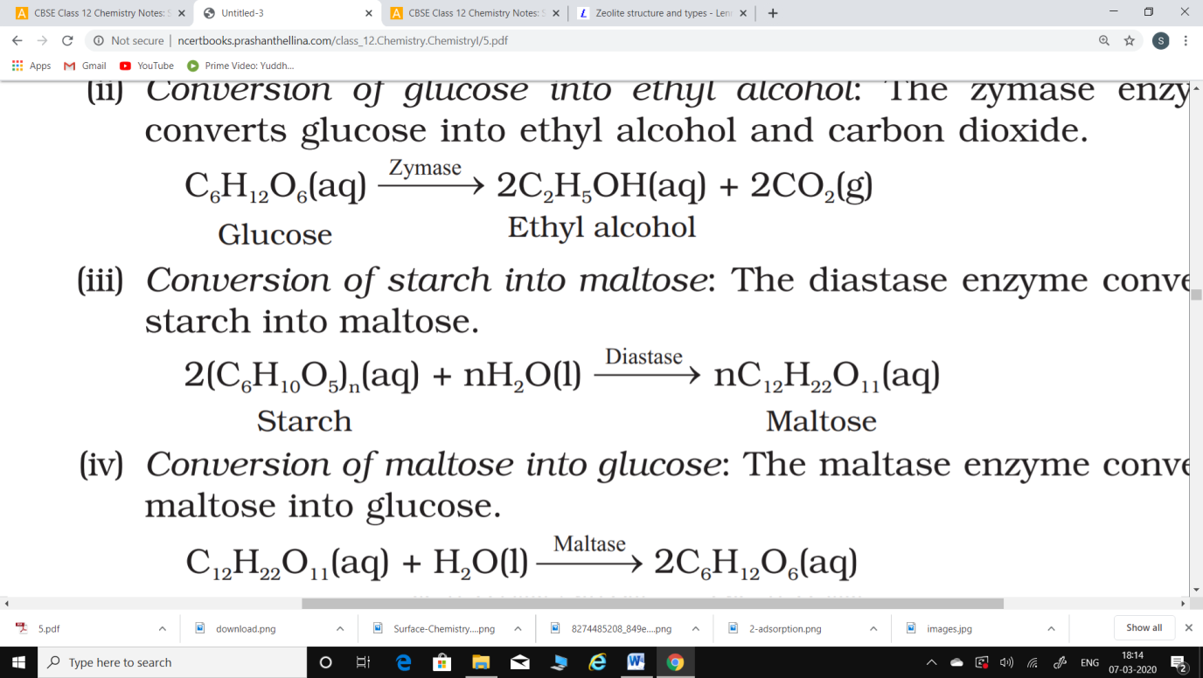

(iv) Conversion of maltose into glucose: The maltase enzyme convert maltose into glucose.

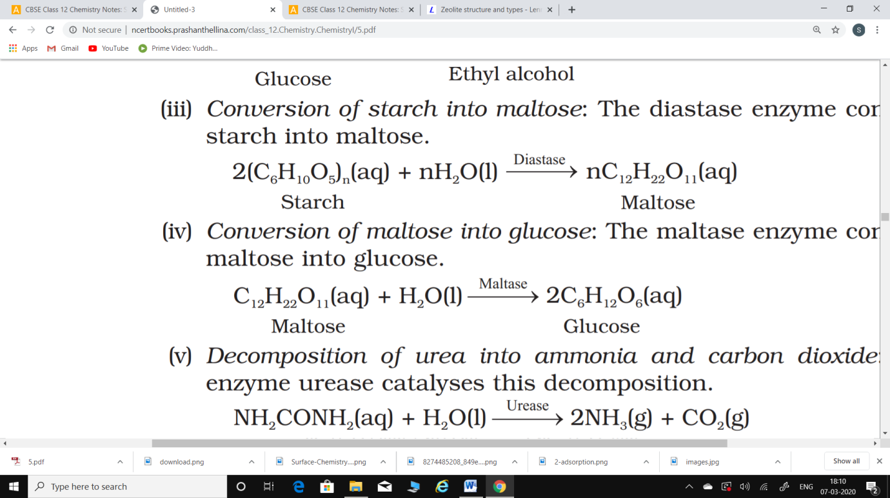

(v) Decomposition of urea into ammonia and carbon dioxide: The enzyme urease catalyses this decomposition.

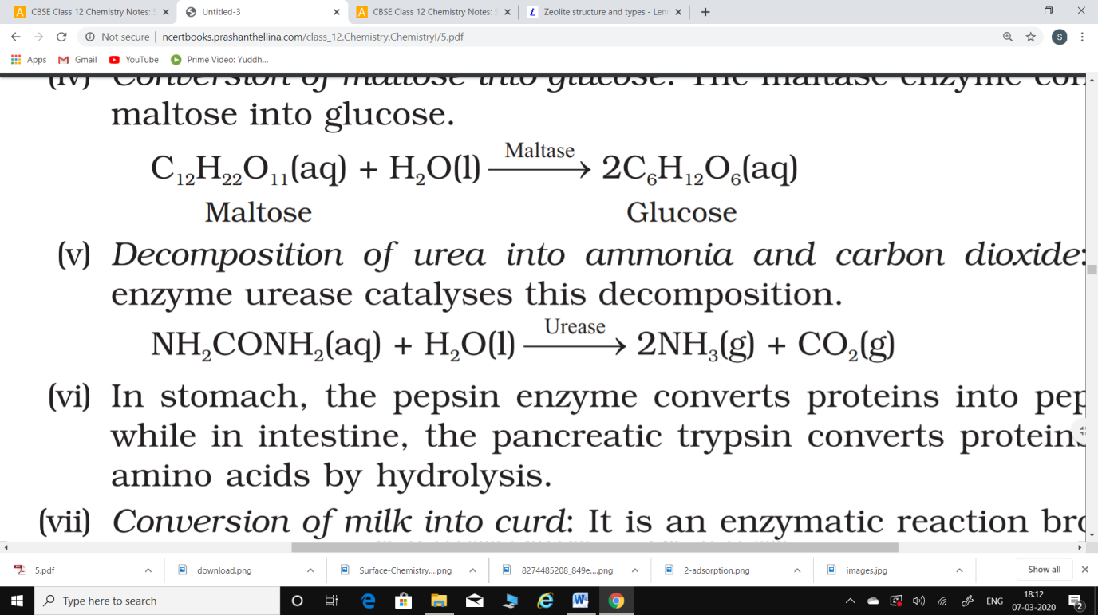

(vi) In stomach, the pepsin enzyme converts proteins into peptides while in intestine, the pancreatic trypsin converts proteins into amino acids by hydrolysis.

(vii) Conversion of milk into curd: It is an enzymatic reaction brought about by lacto bacilli enzyme present in curd.

**Some Enzymatic Reactions:**

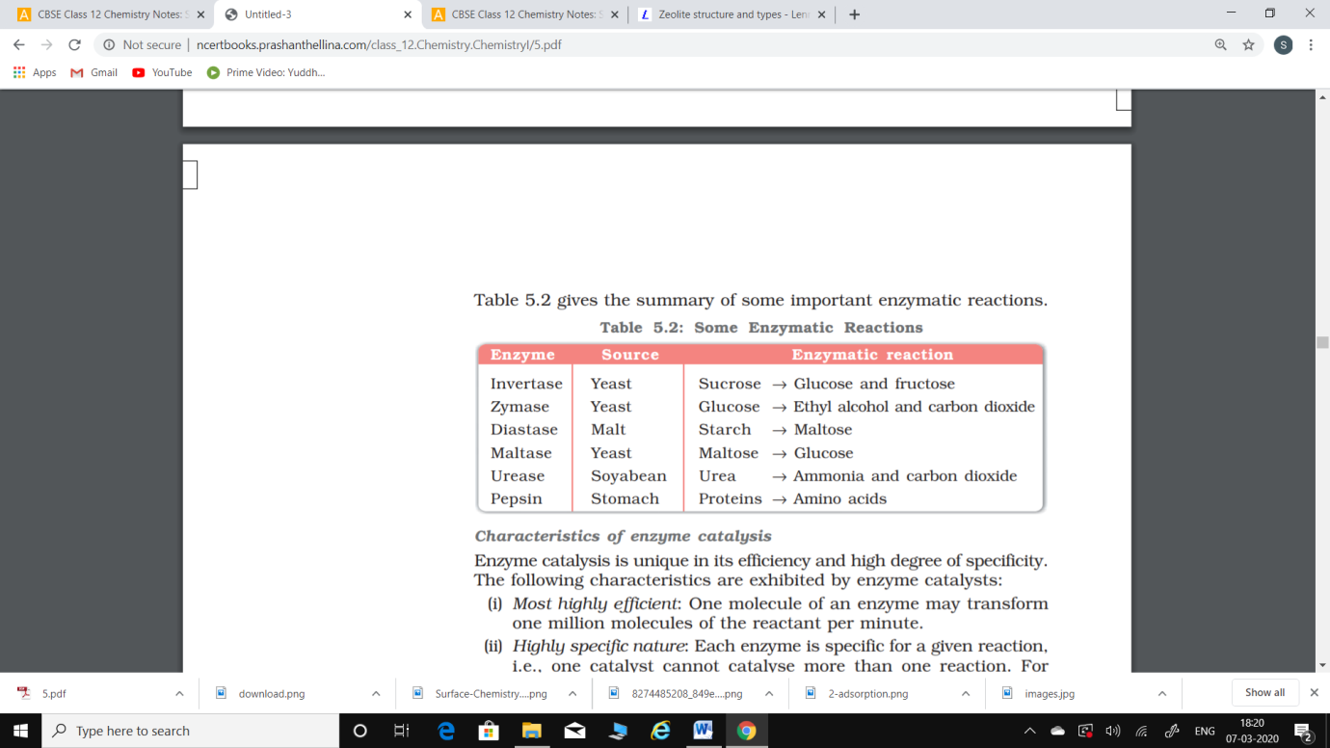

**Characteristics of enzyme catalysis**:

Enzyme catalysis is unique in its efficiency and high degree of specificity.

The following characteristics are exhibited by enzyme catalysts:

1. Most highly efficient: One molecule of an enzyme may transform one million molecules of the reactant per minute.
2. Highly specific nature: Each enzyme is specific for a given reaction, i.e., one catalyst cannot catalyse more than one reaction. For example, the enzyme urease catalyses the hydrolysis of urea only. It does not catalyse hydrolysis of any other amide.
3. Highly active under optimum temperature: The rate of an enzyme reaction becomes maximum at a definite temperature, called the optimum temperature. On either side of the optimum temperature, the enzyme activity decreases. The optimum temperature range for enzymatic activity is 298-310K. Human body temperature being 310 K is suited for enzyme-catalysed reactions.
4. Highly active under optimum pH: The rate of an enzyme-catalysed reaction is maximum at a particular pH called optimum pH, which is between pH values 5-7.
5. Increasing activity in presence of activators and co-enzymes: The enzymatic activity is increased in the presence of certain substances, known as co-enzymes. It has been observed that when a small non-protein (vitamin) is present along with an enzyme, the catalytic activity is enhanced considerably. Activators are generally metal ions such as Na+, Mn2+, Co2+, Cu2+, etc. These metal ions, when weakly bonded to enzyme molecules, increase their catalytic activity. Amylase in presence of sodium chloride i.e., Na+ ions are catalytically very active.
6. Influence of inhibitors and poisons: Like ordinary catalysts, enzymes are also inhibited or poisoned by the presence of certain substances. The inhibitors or poisons interact with the active functional groups on the enzyme surface and often reduce or completely destroy the catalytic activity of the enzymes. The use of many drugs is related to their action as enzyme inhibitors in the body.

**Mechanism of enzyme catalysis**:

There are a number of cavities present on the surface of colloidal particles of enzymes. These cavities are of characteristic shape and possess active groups such as -NH2, -COOH, -SH, -OH, etc. These are actually the active centres on the surface of enzyme particles. The molecules of the reactant (substrate), which have complementary shape, fit into these cavities just like a key fits into a lock. On account of the presence of active groups, an activated complex is formed which then decomposes to yield the products. Thus, the enzyme-catalysed reactions may be considered to proceed in two steps.

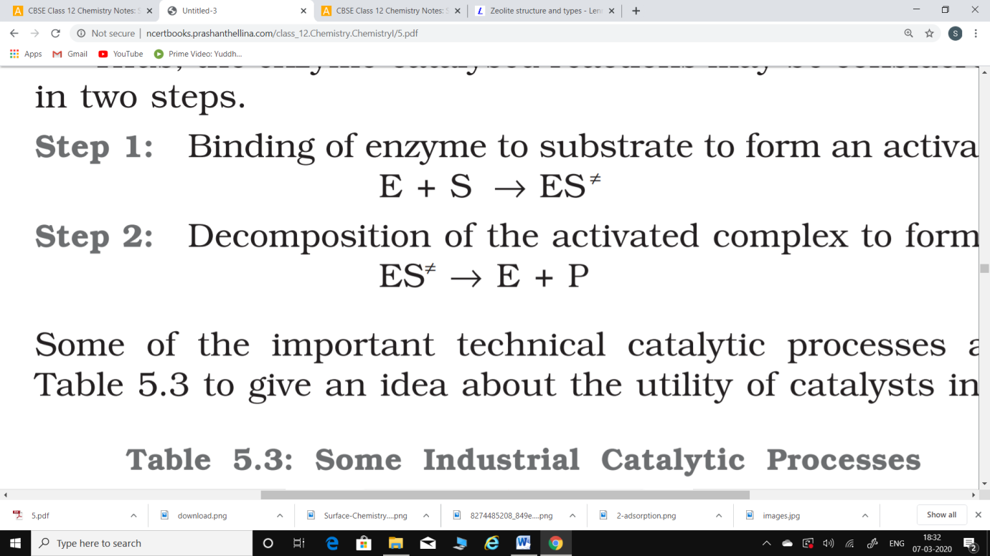Step 1: Binding of enzyme to substrate to form an activated complex.

Step 2: Decomposition of the activated complex to form product.

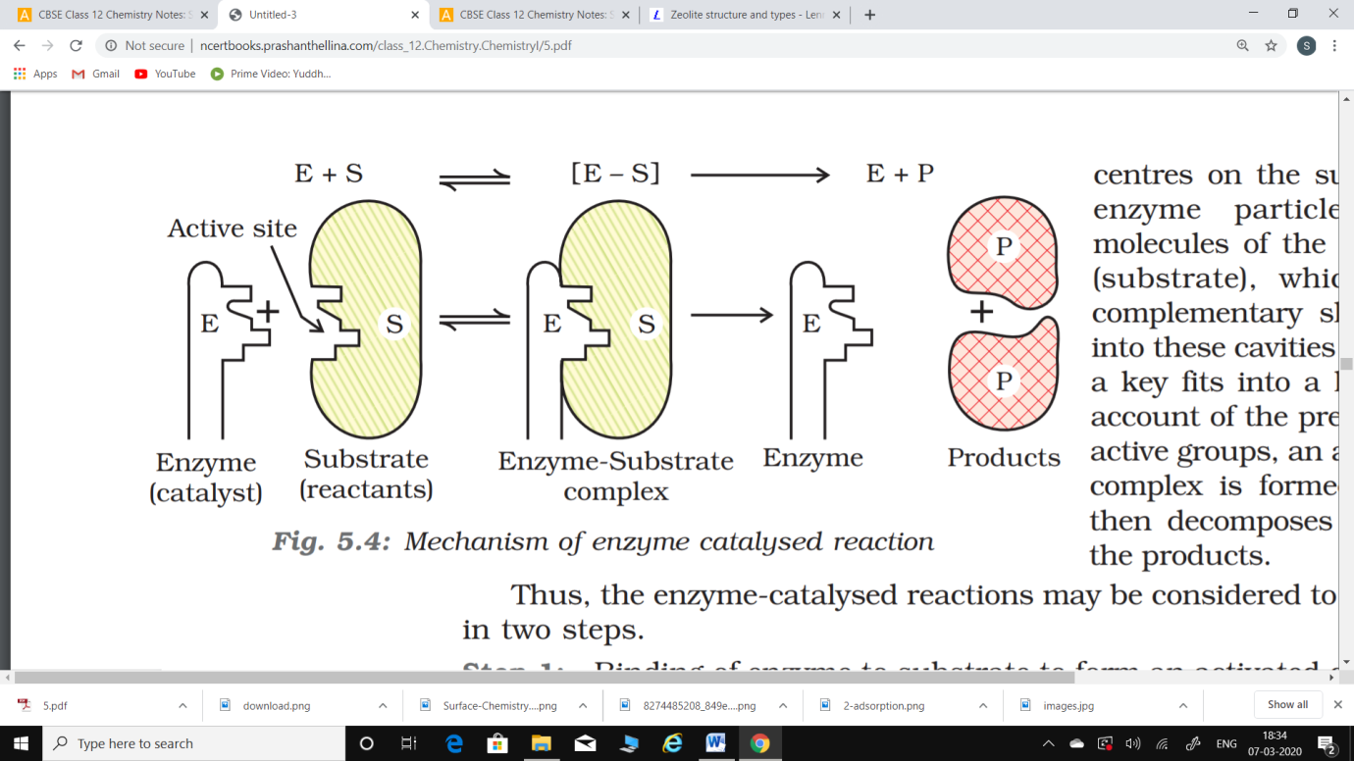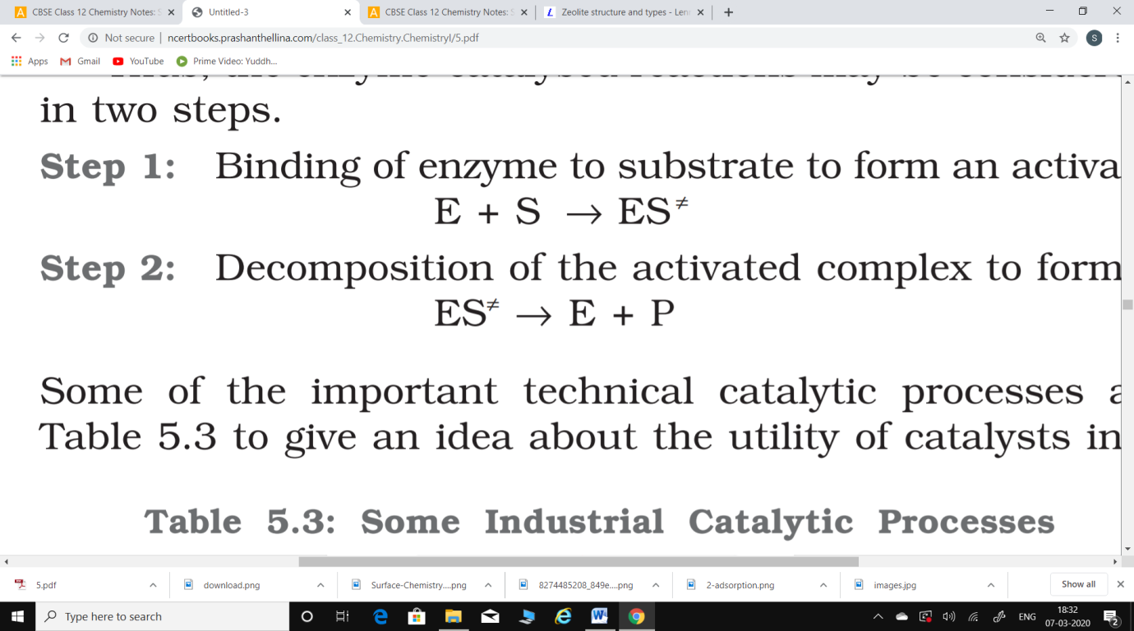

Figure shows the Mechanism of enzyme catalysed reaction

**Catalysts in Industry:**

Some of the important technical catalytic processes are listed in Table, to give an idea about the utility of catalysts in industries.

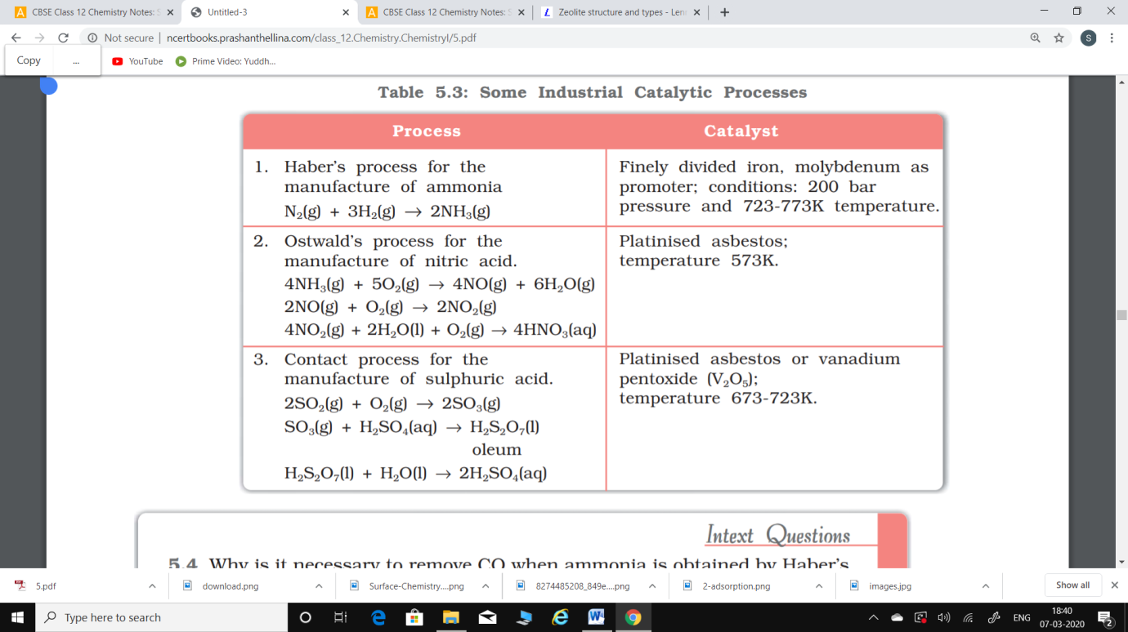

**Colloids:**

A colloid is a mixture in which one substance of microscopically dispersed insoluble or soluble particles is suspended throughout another substance.

A colloid is a heterogeneous system in which one substance is dispersed (dispersed phase) as very fine particles in another substance called dispersion medium.

The essential difference between a solution and a colloid is that of particle size. While in a solution, the constituent particles are ions or small molecules, in a colloid, the dispersed phase may consist of particles of a single macromolecule (such as protein or synthetic polymer) or an aggregate of many atoms, ions or molecules. Colloidal particles are larger than simple molecules but small enough to remain suspended. Their range of diameters is between 1 and 1000 nm (10–9 to 10–6 m).

Colloidal particles have an enormous surface area per unit mass as a result of their small size. Consider a cube with 1 cm side. It has a total surface area of 6 cm2 . If it were divided equally into 1012 cubes, the cubes would be the size of large colloidal particles and have a total surface area of 60,000 cm2 or 6 m2 . This enormous surface area leads to some special properties of colloids to be discussed later in this Unit.

**Classification of colloids**:

Colloids are classified on the basis of the following criteria:

1. Physical state of dispersed phase and dispersion medium.
2. Nature of interaction between dispersed phase and dispersion medium.
3. Type of particles of the dispersed phase.

Depending upon whether the dispersed phase and the dispersion medium are solids, liquids or gases, eight types of colloidal systems are possible. A gas mixed with another gas forms a homogeneous mixture and hence is not a colloidal system. The examples of the various types of colloids along with their typical names are listed in Table.

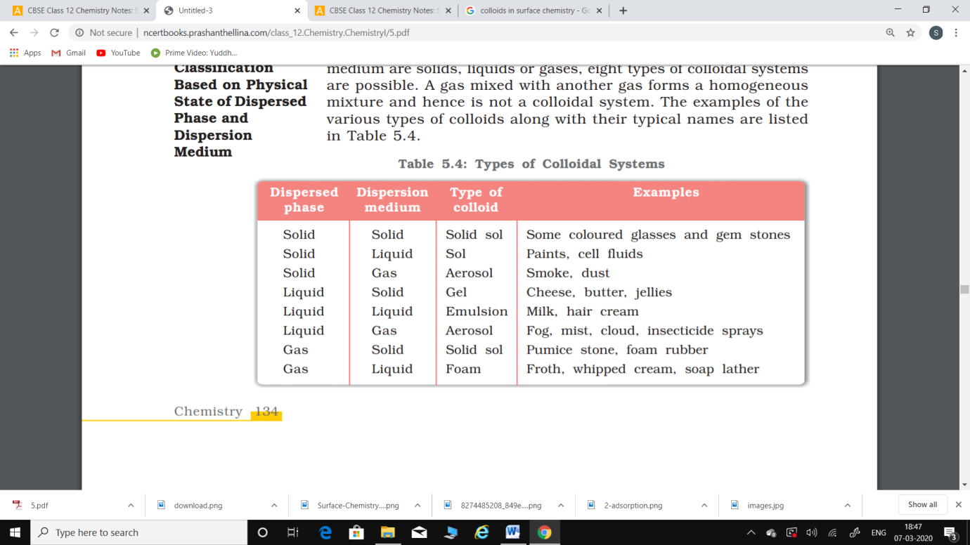 Types of colloidal systems

Many familiar commercial products and natural objects are colloids. For example, whipped cream is a foam, which is a gas dispersed in a liquid. Fire fighting foams, used at emergency airplane landings are also colloidal systems. Most biological fluids are aqueous sols (solids dispersed in water). Within a typical cell, proteins and nucleic acids are colloidal-sized particles dispersed in an aqueous solution of ions and small molecules.

Out of the various types of colloids given in Table, the most common are sols (solids in liquids), gels (liquids in solids) and emulsions (liquids in liquids). However, in the present Unit, we shall take up discussion of the ‘sols’ and ‘emulsions’ only. Further, it may be mentioned that if the dispersion medium is water, the sol is called aquasol or hydrosol and if the dispersion medium is alcohol, it is called alcosol and so on.

**Classification Based on Nature of Interaction between Dispersed Phase and Dispersion Medium:**

Depending upon the nature of interaction between the dispersed phase and the dispersion medium, colloidal sols are divided into two categories, namely, lyophilic (solvent attracting) and lyophobic (solvent repelling). If water is the dispersion medium, the terms used are hydrophilic and hydrophobic.

1. Lyophilic colloids: The word ‘lyophilic’ means liquid-loving. Colloidal sols directly formed by mixing substances like gum, gelatine, starch, rubber, etc., with a suitable liquid (the dispersion medium) are called lyophilic sols. An important characteristic of these sols is that if the dispersion medium is separated from the dispersed phase (say by evaporation), the sol can be reconstituted by simply remixing with the dispersion medium. That is why these sols are also called reversible sols. Furthermore, these sols are quite stable and cannot be easily coagulated as discussed later.
2. Lyophobic colloids: The word ‘lyophobic’ means liquid-hating. Substances like metals, their sulphides, etc., when simply mixed with the dispersion medium do not form the colloidal sol. Their colloidal sols can be prepared only by special methods (as discussed later). Such sols are called lyophobic sols. These sols are readily precipitated (or coagulated) on the addition of small amounts of electrolytes, by heating or by shaking and hence, are not stable. Further, once precipitated, they do not give back the colloidal sol by simple addition of the dispersion medium. Hence, these sols are also called irreversible sols. Lyophobic sols need stabilising agents for their preservation.

**Classification Based on Type of Particles of the Dispersed Phase, Multimolecular, Macromolecular and Associated Colloids:**

Depending upon the type of the particles of the dispersed phase, colloids are classified as: multimolecular, macromolecular and associated colloids.

1. Multimolecular colloids: On dissolution, a large number of atoms or smaller molecules of a substance aggregate together to form species having size in the colloidal range (diameter<1nm). The species thus formed are called multimolecular colloids. For example, a gold sol may contain particles of various sizes having many atoms. Sulphur sol consists of particles containing a thousand or more of S8 sulphur molecules.
2. Macromolecular colloids: Macromoleculesin suitable solvents form solutions in which the size of the macromolecules may be in the colloidal range. Such systems are called macromolecular colloids. These colloids are quite stable and resemble true solutions in many respects. Examples of naturally occurring macromolecules are starch, cellulose, proteins and enzymes; and those of man-made macromolecules are polythene, nylon, polystyrene, synthetic rubber, etc,
3. Associated colloids (Micelles): There are some substances which at low concentrations behave as normal strong electrolytes, but at higher concentrations exhibit colloidal behaviour due to the formation of aggregates. The aggregated particles thus formed are called micelles. These are also known as associated colloids. The formation of micelles takes place only above a particular temperature called Kraft temperature (Tk) and above a particular concentration called critical micelle concentration (CMC). On dilution, these colloids revert back to individual ions. Surface active agents such as soaps and synthetic detergents belong to this class. For soaps, the CMC is 10–4 to 10–3 mol L–1. These colloids have both lyophobic and lyophilic parts. Micelles may contain as many as 100 molecules or more.

**Preparation of Colloids:**

A few important methods for the preparation of colloids are as follows:

1. Chemical methods:

Colloidal solutions can be prepared by chemical reactions leading to formation of molecules by double decomposition, oxidation, reduction or hydrolysis. These molecules then aggregate leading to formation of sols.

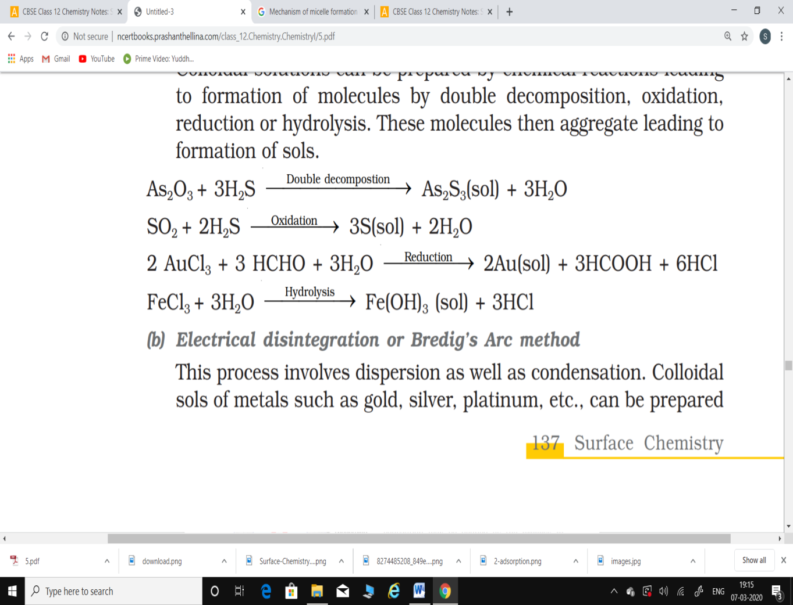

1. Electrical disintegration or Bredig’s Arc method: This process involves dispersion as well as condensation. Colloidal sols of metals such as gold, silver, platinum, etc., can be prepared by this method. In this method, electric arc is struck between electrodes of the metal immersed in the dispersion medium.The intense heat produced vapourises the metal, which then condenses to form particles of colloidal size.
2. Peptization:

Peptization may be defined as the process of converting a precipitate into colloidal sol by shaking it with dispersion medium in the presence of a small amount of electrolyte. The electrolyte used for this purpose is called peptizing agent. This method is applied, generally, to convert a freshly prepared precipitate into a colloidal sol. During peptization, the precipitate adsorbs one of the ions of the electrolyte on its surface. This causes the development of positive or negative charge on precipitates, which ultimately break up into smaller particles of the size of a colloid.

**Purification of Colloidal Solutions:**

Colloidal solutions when prepared, generally contain excessive amount of electrolytes and some other soluble impurities. While the presence of traces of electrolyte is essential for the stability of the colloidal solution, larger quantities coagulate it. It is, therefore, necessary to reduce the concentration of these soluble impurities to a requisite minimum. The process used for reducing the amount of impurities to a requisite minimum is known as purification of colloidal solution.

The purification of colloidal solution is carried out by the following mehods:

1. Dialysis: It is a process of removing a dissolved substance from a colloidal solution by means of diffusion through a suitable membrane. Since particles (ions or smaller molecules) in a true solution can pass through animal membrane (bladder) or parchment paper or cellophane sheet but not the colloidal particles, the membrane can be used for dialysis. The apparatus used for this purpose is called dialyser. A bag of suitable membrane containing the colloidal solution is suspended in a vessel through which fresh water is continuously flowing. The molecules and ions diffuse through membrane into the outer water and pure colloidal solution is left behind.

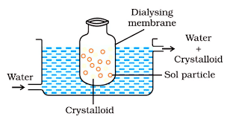

1. Electro-dialysis: Ordinarily, the process of dialysis is quite slow. It can be made faster by applying an electric field if the dissolved substance in the impure colloidal solution is only an electrolyte. The process is then named electrodialysis. The colloidal solution is placed in a bag of suitable membrane while pure water is taken outside. Electrodes are fitted in the compartment as shown in Fig.The ions present in the colloidal solution migrate out to the oppositely charged electrodes.

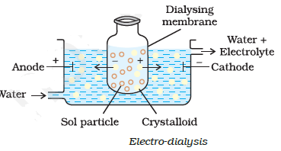

1. Ultrafiltration: Ultrafiltration is the process of separating the colloidal particles from the solvent and soluble solutes present in the colloidal solution by specially prepared filters, which are permeable to all substances except the colloidal particles. Colloidal particles can pass through ordinary filter paper because the pores are too large. However, the pores of filter paper can be reduced in size by impregnating with colloidion solution to stop the flow of colloidal particles. The usual colloidion is a 4% solution of nitrocellulose in a mixture of alcohol and ether. An ultra-filter paper may be prepared by soaking the filter paper in a colloidion solution, hardening by formaldehyde and then finally drying it. Thus, by using ultra-filter paper, the colloidal particles are separated from rest of the materials. Ultrafiltration is a slow process. To speed up the process, pressure or suction is applied. The colloidal particles left on the ultra-filter paper are then stirred with fresh dispersion medium (solvent) to get a pure colloidal solution

**Properties of colloidal Solutions:**

Various properties exhibited by the colloidal solutions are described below: (i) Colligative properties: Colloidal particles being bigger aggregates, the number of particles in a colloidal solution is comparatively small as compared to a true solution. Hence, the values of colligative properties (osmotic pressure, lowering in vapour pressure, depression in freezing point and elevation in boiling point) are of small order as compared to values shown by true solutions at same concentrations. (ii) Tyndall effect: If a homogeneous solution placed in dark is observed in the direction of light, it appears clear and, if it is observed from a direction at right angles to the direction of light beam, it appears perfectly dark. Colloidal solutions viewed in the same way may also appear reasonably clear or translucent by the transmitted light but they show a mild to strong opalescence, when viewed at right angles to the passage of light, i.e., the path of the beam is illuminated by a bluish light. This effect was first observed by Faraday and later studied in detail by Tyndall and is termed as Tyndall effect. The bright cone of the light is called Tyndall cone. The Tyndall effect is due to the fact that colloidal particles scatter light in all directions in space. This scattering of light illuminates the path of beam in the colloidal dispersion. Tyndall effect can be observed during the projection of picture in the cinema hall due to scattering of light by dust and smoke particles present there.

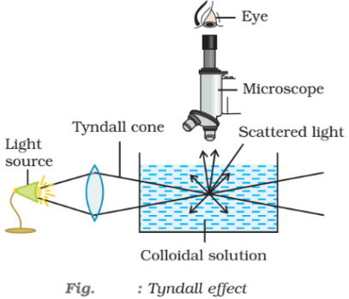

**Emulsions:**

These are liquid-liquid colloidal systems, i.e., the dispersion of finely divided droplets in another liquid. If a mixture of two immiscible or partially miscible liquids is shaken, a coarse dispersion of one liquid in the other is obtained which is called emulsion. Generally, one of the two liquids is water. There are two types of emulsions.

1. Oil dispersed in water (O/W type) and
2. Water dispersed in oil (W/O type). In the first system, water acts as dispersion medium. Examples of this type of emulsion are milk and vanishing cream. In milk, liquid fat is dispersed in water. In the second system, oil acts as dispersion medium. Common examples of this type are butter and cream. Emulsions of oil in water are unstable and sometimes they separate into two layers on standing. For stabilisation of an emulsion, a third component called emulsifying agent is usually added. The emulsifying agent forms an interfacial film between suspended particles and the medium. The principal emulsifying agents for O/W emulsions are proteins, gums, natural and synthetic soaps, etc., and for W/O, heavy metal salts of fatty acids, long chain alcohols, lampblack, etc. Emulsions can be diluted with any amount of the dispersion medium. On the other hand, the dispersed liquid when mixed, forms a separate layer. The droplets in emulsions are often negatively charged and can be precipitated by electrolytes. They also show Brownian movement and Tyndall effect. Emulsions can be broken into constituent liquids by heating, freezing, centrifuging, etc.

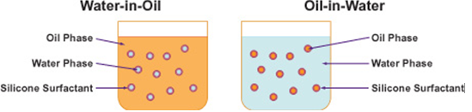

**Colloids Around Us:**

Most of the substances, we come across in our daily life, are colloids. The meals we eat, the clothes we wear, the wooden furniture we use, the houses we live in, the newspapers we read, are largely composed of colloids. Following are the interesting and noteworthy examples of colloids:

1. Blue colour of the sky: Dust particles along with water suspended in air scatter blue light which reaches our eyes and the sky looks blue to us.
2. Fog, mist and rain: When a large mass of air containing dust particles, is cooled below its dewpoint, the moisture from the air condenses on the surfaces of these particles forming fine droplets. These droplets being colloidal in nature continue to float in air in the form of mist or fog. Clouds are aerosols having small droplets of water suspended in air. On account of condensation in the upper atmosphere, the colloidal droplets of water grow bigger and bigger in size, till they come down in the form of rain. Sometimes, the rainfall occurs when two oppositely charged clouds meet. It is possible to cause artificial rain by throwing electrified sand or spraying a sol carrying charge opposite to the one on clouds from an aeroplane.
3. Food articles: Milk, butter, halwa, ice creams, fruit juices, etc., are all colloids in one form or the other.
4. Blood: It is a colloidal solution of an albuminoid substance. The styptic action of alum and ferric chloride solution is due to coagulation of blood forming a clot which stops further bleeding.
5. Soils: Fertile soils are colloidal in nature in which humus acts as a protective colloid. On account of colloidal nature, soils adsorb moisture and nourishing materials.
6. Formation of delta: River water is a colloidal solution of clay. Sea water contains a number of electrolytes. When river water meets the sea water, the electrolytes present in sea water coagulate the colloidal solution of clay resulting in its deposition with the formation of delta.

**Applications of colloids:**

Colloids are widely used in the industry. Following are some examples:

1. Electrical precipitation of smoke: Smoke is a colloidal solution of solid particles such as carbon, arsenic compounds, dust, etc., in air. The smoke, before it comes out from the chimney, is led through a chamber containing plates having a charge opposite to that carried by smoke particles. The particles on coming in contact with these plates lose their charge and get precipitated. The particles thus settle down on the floor of the chamber. The precipitator is called Cottrell precipitator.
2. Purification of drinking water: The water obtained from natural sources often contains suspended impurities. Alum is added to such water to coagulate the suspended impurities and make water fit for drinking purposes.
3. Medicines: Most of the medicines are colloidal in nature. For example, argyrol is a silver sol used as an eye lotion. Colloidal antimony is used in curing kalaazar. Colloidal gold is used for intramuscular injection. Milk of magnesia, an emulsion, is used for stomach disorders. Colloidal medicines are more effective because they have large surface area and are therefore easily assimilated.
4. Tanning: Animal hides are colloidal in nature. When a hide, which has positively charged particles, is soaked in tannin, which contains negatively charged colloidal particles, mutual coagulation takes place. This results in the hardening of leather. This process is termed as tanning. Chromium salts are also used in place of tannin.
5. Photographic plates and films: Photographic plates or films are prepared by coating an emulsion of the light sensitive silver bromide in gelatin over glass plates or celluloid films.
6. Rubber industry: Latex is a colloidal solution of rubber particles which are negatively charged. Rubber is obtained by coagulation of latex.
7. Industrial products: Paints, inks, synthetic plastics, rubber, graphite lubricants, cement, etc., are all colloidal solutions.

**Conclusion:**

Surface Chemistry has a major role in various chemical processes such as: Enzymatic reactions at the biological interfaces found in the cell walls and membranes. In the electronics industry, the use in the surface and interface of microchips used in computers.

Adsorption is the phenomenon of attracting and retaining the molecules of a substance on the surface of a solid resulting into a higher concentration on the surface than in the bulk. The substance adsorbed is known as adsorbate and the substance on which adsorption takes place is called adsorbent. In physisorption, adsorbate is held to the adsorbent by weak van der Waals forces, and in chemisorption, adsorbate is held to the adsorbent by strong chemical bond. Almost all solids adsorb gases. The extent of adsorption of a gas on a solid depends upon nature of gas, nature of solid, surface area of the solid, pressure of gas and temperature of gas. The relationship between the extent of adsorption (x/m) and pressure of the gas at constant temperature is known as adsorption isotherm. A catalyst is a substance which enhances the rate of a chemical reaction without itself getting used up in the reaction. The phenomenon using catalyst is known as catalysis. In homogeneous catalysis, the catalyst is in the same phase as are the reactants, and in heterogeneous catalysis the catalyst is in a different phase from that of the reactants. Colloidal solutions are intermediate between true solutions and suspensions. The size of the colloidal particles range from 1 to 1000 nm. A colloidal system consists of two phases - the dispersed phase and the dispersion medium. Colloidal systems are classified in three ways depending upon :

1. physical states of the dispersed phase and dispersion medium
2. nature of interaction between the dispersed phase and dispersion medium and
3. nature of particles of dispersed phase. The colloidal systems show interesting optical, mechanical and electrical properties. The process of changing the colloidal particles in a sol into the insoluble precipitate by addition of some suitable electrolytes is known as coagulation.

Emulsions are colloidal systems in which both dispersed phase and dispersion medium are liquids. These can be of:

1. Oil in water type and
2. Water in oil type. The process of making emulsion is known as emulsification. To stabilise an emulsion, an emulsifying agent or emulsifier is added. Soaps and detergents are most frequently used as emulsifiers. Colloids find several applications in industry as well as in daily life.

**References:**

* Basics of chemistry
* NCERT textbook of class 12
* [www.wikipedia.com](http://www.wikipedia.com)
* <https://schools.aglasem.com/7292>
* <https://www.toppr.com/guides/chemistry/surface-chemistry/adsorption-isotherm/>
* <https://www.askiitians.com/iit-jee-chemistry/physical-chemistry/surface-chemistry/>
* <https://en.wikipedia.org/wiki/Catalysis>
* <https://byjus.com/jee/surface-chemistry/>

**Acknowledgement:**

We wish to express our deep gratitude and sincere thanks to our chemistry Faculty, Dr.Ch.Srilakshmi madam and Dr.S.Janardhan sir,Gitam University, Bengaluru for their encouragement and for the facilities they provided for the case study.We sincerely appreciate their magnanimity by taking us into his field for which we shall remain indebted to them.We extend our heartly thanks to them who guided us to successful completion of this case study. We take this opportunity to express our deep sense of gratitude for their invaluable guidance, constant encouragement, immense motivation, which has sustained my efforts at all the stages of this case study…..